|  |  |  |  |
| --- | --- | --- | --- |
| DRAFT TECHNICAL MEMORANDUM | | | |
| DATE |  |  | |
| TO |  | | |
| CC |  | | |
| FROM |  | | EMAIL feng.li@wsp.com |
| selection and weighting of ground motion models for the Antapaccay project in Central Chile | | | |

This technical memorandum summarizes an evaluation by Golder Associates USA Inc. (Golder) of available ground motion models (GMMs) to develop the ground motion modeling logic tree for subduction zone earthquakes. The evaluation was undertaken to support probabilistic and deterministic seismic hazard analyses (PSHA and DSHA) for the Antapaccay project site in central Chile. The considered GMMs include four GMMs developed as products of the Next Generation Attenuation project for subduction zone earthquake (NGA-Sub project) and GMMs developed prior the NGA-Sub project (pre-NGA GMMs).

# introduction

Ground motion modeling is a key component of any seismic hazard analysis. Typically, a suite of empirical ground motion models (GMMs) is selected and used to estimate the source-to-site attenuation of earthquake ground motions at horizontal peak ground acceleration (PGA) and at other spectral periods (usually 5%-damped). GMMs are selected based on the similarity between the tectonic and geologic conditions surrounding the site and those where the earthquake motions were recorded and used to derive the GMMs.

Four GMMs for subduction zone earthquakes became available in October 2020. These GMMs are: Abrahamson and Gülerce (2020, AG), Kuehn, Bozorgnia, Campbell, and Gregor (2020, KBCG), Parker, Stewart, Boore, Atkinson, and Hassani (2020, PSHAB), and Si, Midorikawa, and Kishida (2020, SMK). These GMMs were developed as a part of the NGA-Sub project. These NGA-Sub GMMs, however, are new and have not been broadly implemented in engineering projects. It is not understood yet if NGA-Sub GMMs should be supplemented with pre-NGA GMMs and what relative weights should be assigned to each NGA-Sub and/or pre-NGA-Sub GMMs. To apply the best available science to the needs of this project, we evaluated the NGA-Sub GMMs by:

* Comparing model features of the 2020 NGA-Sub GMMs; and
* Comparing ground motions predicted for selected earthquake scenarios using NGA-Sub GMMs and pre-NGA-Sub GMMs.

We used the qualitative comparison results to develop a ground motion modeling logic tree with weights for selected GMMs.

# GMM evalution

This section describes the comparison of the NGA-Sub GMMs. A GMM typically comprises a median and an aleatory variability (i.e., sigma) prediction model. The median model is typically a function of the earthquake type, earthquake magnitude, source-to-site distance, and site ground condition of the recording station. A median model thus generally comprises a model constant, a magnitude term, a travel path term, a depth term, and a site amplification term. The sigma model quantifies the natural variability in recorded ground motions. We qualitatively evaluated both the median and sigma prediction models.

## Features in NGA-Sub

Compared to pre-NGA GMMs, the NGA-Sub GMMs have the new model features described below:

* The NGA-Sub GMMs were developed based on the latest and by far the largest strong motion database for subduction zone earthquakes, i.e., NGA-Sub strong motion database (Bozorgnia and Stewart 2020). This database contains more than 70,000, three-component earthquake records from 1,880 earthquakes. Out of these earthquakes, almost 1,000 earthquakes were assigned with an event type, e.g., interface or in-slab earthquake source. The ground motion records were collected from seven subduction zone regions: Alaska, Central America and Mexico, Cascadia, Japan, New Zealand, South America, and Taiwan.
* Pre-NGA GMMs were developed based on an ergodic assumption with only a global model and no quantified regional differences. Three of NGA-Sub GMMs, however, consist of a global model and regional models for the seven regions where earthquake records have been collected. The exception is the SMK model that was developed using only Japan strong-motion records.
* The GMM developers also recommended a within-model epistemic uncertainty to represent regional variations in earthquake ground motions.
* The NGA-Sub GMMs also incorporated the latest scientific understanding on earthquake magnitude-breaking point (MBP) as described by Archuleta and Ji (2018) for in-slab earthquakes, and by Campbell (2020) for interface earthquakes. The earthquake ground motions at a site generally increases as the earthquake magnitude increases. The rate of increase is referred to as the magnitude scaling rate (MSR). It is generally considered there is a break in the MSR due to ground motion saturation at short distances. The selection of an MBP has significant impact on seismic hazard estimates at a site, especially for a DSHA to estimate ground motions for a maximum credible earthquake (MCE). There are, however, only a limited number of well recorded megathrust earthquakes such as Maule, Chile (2010) and Tohoku, Japan (2011) or great in-slab earthquakes to constrain the MBP and MSR at very large magnitudes. The uncertainty in the MBP and MSR, therefore, is high. Nevertheless, the NGA-Sub GMMs incorporate the latest scientific understanding on MBP.
* The NGA-Sub GMMs were developed to predict earthquake ground motions for structure periods from PGA to 10 seconds and for broad ranges of earthquake magnitudes, source-to-site distances, and site conditions, as listed in Table 1.

Table : NGA-Sub GMM Applicability

| Parameter | PSHAB | KBCG | AG | SMK |
| --- | --- | --- | --- | --- |
| **Interface** | | | | |
| Moment Magnitude (Mw) | [4.5, 9.5] | [5, 9.5] | [5.0, 9.5] | [5.5, 9.1] |
| Rrup (km) | [20, 1000] | [10, 1000] | [0, 500] forearc1 | [14, 300] |
| VS30 (m/s) | [150, 2000] | [150, 1500] | [100, 1500] | [100, 1900] |
| Depth (km) | Zhyp: [0, 40] | Ztor: [0, 50] | Independent | Zhyp: [4, 50] |
| **In-slab** | | | | |
| Moment Magnitude (Mw) | [4.5, 8.5] | [5, 8.5] | [5.0, 8.0] | [5.6, 8.3] |
| Rrup (km) | [35, 1000] | [10, 1000] | [0, 500] forearc1 | [18, 300] |
| VS30 (m/s) | [150, 2000] | [150, 1500] | [100, 1500] | [100, 1900] |
| Depth (km) | Zhyp: [0, 200] | Ztor: [0, 200]2 | Ztor: [0, 200] | Zhyp: [18, 100] |

Notes: Mw = earthquake moment magnitude; Rrup = rupture distance; *VS*30 = time-averaged shear-wave velocity in the top 30 m; Zhyp = hypocentral depth; Ztor = top-of-rupture depth

1. Except for the Cascadia region, the model is applicable up to 500 km distances and for back-arc sites.
2. For Columbia, up to 150 km for in-slab events.

## Comparison of Modeling Features Among NGA-Sub GMMs

We compared the modeling features among four NGA-Sub GMMs. Through the comparison, we observed the following key differences:

* *Event type*: SMK modeled the difference in ground motions from in-slab and interface earthquakes as a constant. The other three GMMs model the interface-in-slab differences by other terms as well, such as the depth term and magnitude term.
* *Regional term*: SMK was developed only for Japan; whereas the other three GMMs have both a global model and seven regional models. The other three GMMs considered regional differences in multiple terms such as the constant term, path term, and site term.
* *Forearc or back-arc:* KBCG is the only GMM developed for both forearc and back-arc sites.
* *Aleatory variability:* AG’s aleatory variability varies by region. Japan and South America are the two regions with the greatest aleatory variability. KBCG and PSHAB assumed the aleatory variability is the same for all regions.
* *Within-model epistemic uncertainty:* AG has within-model epistemic uncertainty available for only the global model. PSHAB’s within-model epistemic uncertainty varies by region and event type. KBCG’s within-model epistemic uncertainty was represented by the posterior distributions of model coefficients. KBCG provided 800 samples of model coefficients to represent the continuous posterior distributions.

In summary, we observed that among four NGA-Sub GMMs:

* SMK has relatively different modeling features.
* KBCG is the relatively more complicated GMM.

## Comparison of Predicted Ground Motions Among GMMs

We compared NGA-Sub GMMs (excluding SMK) to a selected suite of pre-NGA GMMs. SMK was excluded because it was developed for Japan only. The selected pre-NGA GMMs include Abrahamson et al. (2016, AEA16, also known as BCHydro2015), Zhao et al. (2006, ZEA06), and Montalva et al. (2017, MEA17). These are well recognized and commonly used pre-NGA GMMs for subduction zone earthquakes. Among the pre-NGA GMMs, MEA17 was developed specifically for the Chile subduction zone.

The comparison focused on the South American (SA) sub-models, if available. KBCG and PSHAB have separate sub-models for the northern and southern South America. The project sites are close to Latitude 14⁰S, which is within the applicable region of the southern sub-models. The southern sub-models are ideally better constrained models because most of the available strong motion records are from this part of South America.

The comparison was made on both the median predictions and aleatory variability (i.e., sigma).

We compared NGA-Sub GMMs for these earthquake scenarios.

* Mw6, Mw7, Mw8 and Mw9.4 interface earthquakes at a 100 km rupture distance with an assumed hypocentral depth of 50 km.
* Mw6, Mw7, Mw8, and Mw8.4 in-slab earthquakes at an 85 km rupture distance with an assumed top-of-rupture depth (Ztor) of 85 km, and an assumed hypocentral depth of 100 km.

The earthquake scenarios are for a *VS*30 of 800 m/s. This *VS*30 is considered close to the ground condition at the project site.

We used the NGA-Sub and pre-NGA GMMs in the HAZ45.3 PSHA software directly. HAZ45.3 is an open-source software developed by Dr. Abrahamson for seismic hazard assessment.

### Results for Interface Earthquakes

Figure 1 shows comparison results of median spectral accelerations (Sa) for Mw6 and Mw7 subduction interface earthquakes. Note that the median spectral accelerations predicted using ZEA06 are up to 5 seconds because ZEA06 predicts ground motions only up to 5 seconds. Figure 2 shows the same comparison for Mw8 and Mw9.4 interface earthquakes.

Figure 1: Median Acceleration Response Spectra (5%-damped) from Selected GMMs for an (Left) Mw 6 and (Right) Mw7 Interface Earthquake at 100 km Rupture Distance.

Figure 2: Median Acceleration Response Spectra (5%-damped) from Selected GMMs for an (Left) Mw 8 and (Right) Mw9.4 Interface Earthquake at 100 km Rupture Distance.

Figure 1 and Figure 2 show the medians predicted using NGA-Sub GMMs generally fall between those predicted using BCHydro2015 and ZEA06 at periods from PGA to 10 seconds. This is considered reasonable as the BCHydro2015 predicts the average of earthquakes recorded globally, whereas the South America subduction zones are considered capable of generating ground motions greater than the global average. The MEA17 predicted median spectral accelerations are generally similar to those from NGA-sub GMMs up to Mw8 and are close to the lower bound predictions of BCHydro2015 for Mw9. The ZEA06 predicted median spectral accelerations are generally greater than those from the other GMMs.

Figure 3 shows the sigma predictions from selected GMMs. The sigma values of NGA-Sub GMMs are generally greater than those of pre-NGA GMMs. The sigma values from ZEA06 and BCHydro2015 GMMs are generally similar. Note the sigma values from ZEA06 drop dramatically at 5 seconds which is an artifact that ZEA06 predicts sigma up to 5 seconds.

The greater sigma values from NGA-Sub GMMs may be contributed by the observation that *VS*30 is a less effective parameter to capture the site effects in South America (pers. com. Dr. Abrahamson). Hence the sigma values may include some site effects not captured by the *VS*30 term and may potentially be conservative. For this project site, we considered using the sigma predictions from the BCHydro2015 GMMs.

Figure 3: Sigma from Selected GMMs for an (Left) Mw 8 and (Right) Mw9.4 Interface Earthquake at 100 km Rupture Distance.

### Results for In-slab Earthquakes

Figure 4 and Figure 5 show the same comparison for in-slab earthquakes. The medians predicted using NGA-Sub GMMs are generally similar to those predicted using pre-NGA GMMs for Mw 6 and Mw 7 earthquakes. For Mw 8 or greater earthquakes, ZEA06 predicts significantly greater median values at all periods; PSHAB predicts significantly greater medians at short periods up to 0.2 s; MEA17’s predictions are significantly lower between 0.2 and 1.0 s.

Figure 4: Median Acceleration Response Spectra (5%-damped) from Selected GMMs for an (Left) Mw 6 and (Right) Mw7 In-slab Earthquake at 85 km Rupture Distance.

Figure 5: Median Acceleration Response Spectra (5%-damped) from Selected GMMs for an (Left) Mw 8 and (Right) Mw8.4 In-slab Earthquake at 85 km Rupture Distance.

Figure 4 and Figure 5 also show the GMM model-to-model variation is significantly greater for in-slab earthquakes compared to that for interface earthquakes. This result is expected as there are less empirical data available for in-slab earthquakes.

Figure 6 shows the sigma predictions from selected GMMs. The sigma values of NGA-Sub GMMs are generally greater than those of pre-NGA GMMs. The sigma values from ZEA06 and BCHydro2015 GMMs are generally similar. Note the sigma values from ZEA06 drop dramatically at 5 seconds as an artifact that ZEA06 predicts sigma only up to 5 seconds. The greater sigma values from NGA-sub GMMs may be for the same reason as discussed for the interface earthquakes.

Figure 6: Sigma from Selected GMMs for an (Left) Mw7 and (Right) Mw8.4 In-slab Earthquake at 85 km Rupture Distance.

# GMM Selection and Weighting

We used the qualitative comparison presented in Section 2 above to select and weight GMMs for this project. Figure 7 and Figure 8 show the selected median GMMs and associated weights. We recommend using the AEA16 (a.k.a. BCHydro2015) sigma model as the preferred model and ±0.1 natural log units as the lower- and upper-bound models.

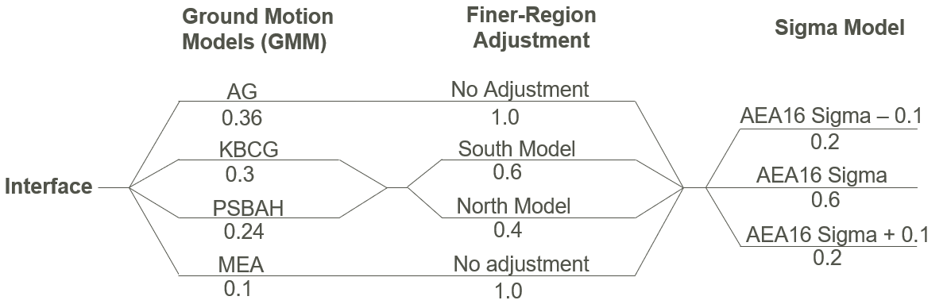

Figure 7: Ground Motion Model Logic Tree for Interface Earthquakes.

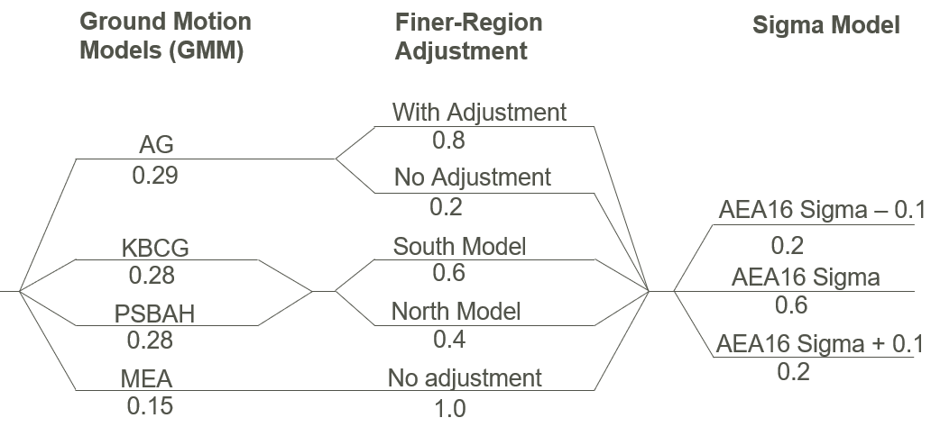

Figure 8: Ground Motion Model Logic Tree for In-slab Earthquakes.

## GMM Selection and Weighting Considerations

We selected and weighted GMMs with the following considerations:

* Golder considers the NGA-Sub GMMs are superior to pre-NGA GMMs because they:
  + Were developed based on the largest and most robust available earthquake strong motion database;
  + Incorporate best available science;
  + Have more complex modeling features;
  + Have broader applicability, e.g., structure period from PGA to 10 seconds; and
  + Include sub-models specifically for South America.
* For interface earthquakes, AG and KBCG were weighted slightly more because their modeling features are more advanced than PSHAB’s. AG was weighted the highest because our experience from projects in other subduction zone regions indicates AG is a relatively more robust NGA-sub model.
* For in-slab earthquakes, we weighted the selected NGA-Sub GMMs equally because there is no strong evidence supporting one model over the others.
* The NGA-Sub GMMs are complemented by MEA. This is because MEA was developed specifically for Chile subduction zones and is a recognized model in South America. MEA, however, was assigned a relatively low weight because it was developed based on a significantly smaller strong motion database.

## Finer-region Adjustment

Drouet et al. (2017) and Arteta et al. (2021, under review) show that recorded ground motions show considerable regional attenuation variations, i.e., the ground motions are larger in Chile and much smaller in Ecuador and Columbia. The trend hinges around Southern Peru and Northern Chile, where this project is. The NGA-sub GMMs, however, were constrained using strong-motion data mostly recorded in the southern South America. We therefore consider applying a finer-region adjustment to GMMs which were developed using largely southern data, e.g., AG, or using southern data only, e.g., KBCG south.

For GMMs, i.e., KBCG and PSHAB, that have separate sub-models for the southern and northern South America, we included both sub-models to take into account the regional attenuation variation. We weighted the southern sub-models slightly more because the project site is slightly south to the boundary (at about 10⁰S) between the southern and northern South America. For the other GMMs, i.e., AG, that do not have separate sub-models for the southern and northern South America, we plotted the between-event residuals along latitudes, fitted a linear trend line to the data, and used the approximate slope of the trend line as the finer-region adjustment.

Figure 9 shows between-event residuals along latitudes for interface earthquakes. A linear trend line was fitted to the residuals. There is no noticeable non-zero trend in this figure. We therefore consider the finer-region adjustment for AG is negligible.

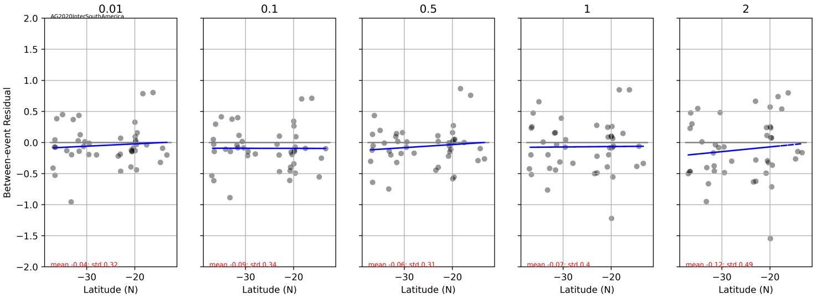

Figure 9: Between-Event Residuals Versus Latitude from AG South American Model for Interface Earthquakes.

Figure 10 show between-event residuals along latitudes for in-slab earthquakes. Similarly, a linear trend line was fitted to the residuals. There is a noticeable non-zero trend in these figures. We estimated the approximate slopes of the fitting trend lines and used them as the finer-region adjustment. The period-dependent finer-region adjustments are listed in Table 2.

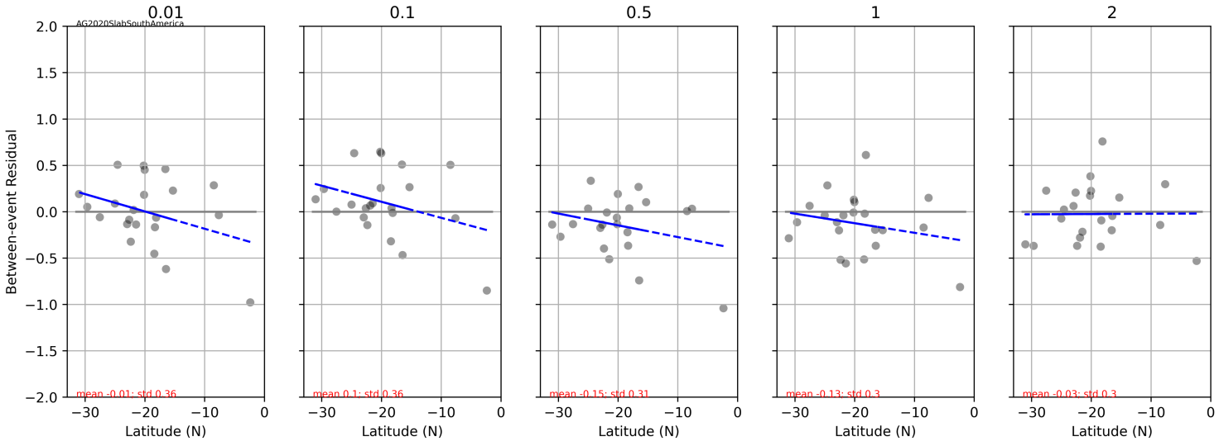

Figure 10: Between-Event Residuals Versus Latitude from AG South American Model for In-slab Earthquakes.

Table : Finer-region Adjustment for In-slab Earthquakes

| GMM | Finer-region Adjustment in Natural Log Scale | | | | |
| --- | --- | --- | --- | --- | --- |
| 0.01s | 0.1s | 0.5s | 1s | 2s |
| AG | -0.1 | zero | -0.2 | -0.2 | zero |

## Within-model Epistemic Uncertainty

Figure 11 and Figure 12 show the epistemic uncertainty captured by the selected GMMs for various interface and in-slab earthquake scenarios, respectively. The average epistemic uncertainty is about 0.2 to 0.3 natural log units, which is comparable to the within-model epistemic uncertainty estimate (i.e., about 0.15 to 0.2 natural log units) from PSHAB and KBCG models. This result indicates the selected GMMs captured sufficient epistemic uncertainty and hence no additional GMM was included.

Figure 11 and Figure 12 also shows that the epistemic uncertainty is generally lower for Mw7 and Mw8 interface earthquakes and Mw6 and Mw7 in-slab earthquakes because there are more observed ground motions available to constrain a GMM.

Figure 11: Epistemic Uncertainty Captured by the Selected GMMs for Selected Interface Earthquake Scenarios.

Figure 12: Epistemic Uncertainty Captured by the Selected GMMs for Selected In-slab Earthquake Scenarios.

# Summary and limitations

This technical memorandum presents Golder’s evaluation and selection of GMMs for the project site. We developed a logic tree for GMMs based on these evaluation results. Section 3 summarizes the GMMs and weights developed for this study.

There are several limitations to this evaluation including:

* Dr. Chiou and his team of researchers are developing the fifth NGA-Sub GMM. This GMM was not available for this project. This evaluation, therefore, could not include this GMM.
* The evaluation is qualitative. Quantitative examination of the GMMs regarding model residuals may result in more robust selection and weighting of available GMMs.

# Closing

Golder Associates USA Inc. provides these results to support seismic analysis and design of the Antapaccay project in Chile. The conclusions and recommendations have been developed specifically for the site considering the tectonic setting as interpreted from readily available information. Further studies and new information on the tectonics of the region and the ongoing development of the GMMs may require re-evaluation of the conclusions and recommendations provided in this technical memorandum.

Golder Associates USA Inc.

FL/AH/

|  |  |
| --- | --- |
|  | |
| Distribution: |  |
|  | |
| Attachments: |  |
|  | |
|  | |
| https://golderassociates-my.sharepoint.com/personal/feli_golder_com/documents/projects/2022/formarcelo/perezcaldera_draft_tm_appendix_gmm_agh_fl.docx | |

# References

Abrahamson, N., N. Gregor, and K. Addo, K. 2016. BC Hydro ground motion prediction equations for subduction earthquakes. Earthquake Spectra 32(1): 23-44.

Abrahamson, N. and Gülerce, Z. 2020. Regionalized Ground-Motion Models for Subduction Earthquakes Based on the NGA-SUB Database, Pacific Earthquake Engineering Research Center (PEER) Report 2020/25.

Abrahamson, N.A. and Youngs, R.R., 1992. A stable algorithm for regression analyses using the random effects model. Bulletin of the Seismological Society of America, 82(1), pp.505-510.

Al Atik, L. and Youngs, R.R., 2014. Epistemic uncertainty for NGA-West2 models. Earthquake Spectra, 30(3), pp.1301-1318.

Archuleta, R. and Ji, C. 2018. A look at scaling of ground motion with magnitude. Proceedings of the 11th National Conference on Earthquake Engineering, Los Angeles, CA.

Arteta, C.A., Pajaro, C.A., Mercado, V., Montejo, J., Arcila, M. and Abrahamson, A. 2021. Ground-motion model for subduction earthquakes in northern South America. Submitted to Earthquake Spectra.

Atkinson, G.M., D.M. Boore. 2003. Empirical Ground-Motion Relations for Subduction-Zone Earthquakes and Their Application to Cascadia and Other Regions: Bulletin of the Seismological Society of America, vol. 93, no. 4, pp. 1703- 1729.

Bozorgnia, Y., Abrahamson, N.A., Atik, L.A., Ancheta, T.D., Atkinson, G.M., Baker, J.W., Baltay, A., Boore, D.M., Campbell, K.W., Chiou, B.S.J. and Darragh, R., 2014. NGA-West2 research project. Earthquake Spectra, 30(3), pp.973-987.

Bozorgnia, Y. and Stewart, J.P. (editor) 2020. Data Resources for NGA-Subduction Project, Pacific Earthquake Engineering Research Center (PEER) Report 2020/02.

Campbell, K.W., 2020. Proposed methodology for estimating the magnitude at which subduction megathrust ground motions and source dimensions exhibit a break in magnitude scaling: Example for 79 global subduction zones. Earthquake Spectra, 36(3), pp.1271-1297.

Drouet, S., Montalva, G., Dimaté, M.C., Castillo, L.F., Fernandez, G.A., Morales, C., Bastias, N., Pirchiner, M., Singaucho, J.C. and Weatherhill, G., 2017, January. Building a ground‐motion logic tree for South America within the GEM‐SARA project framework. In 16th world conference on earthquake engineering January (pp. 9-13).

Kuehn, N., Bozorgnia, Y., Campbell, K.W., and Gregor, N. 2020. Partially Non-Ergodic Ground-Motion Model for Subduction Regions using the NGA-Subduction Database, Pacific Earthquake Engineering Research Center (PEER) Report 2020/04.

Mak, S., Clements, R.A. and Schorlemmer, D., 2017. Empirical evaluation of hierarchical ground‐motion models: Score uncertainty and model weighting. Bulletin of the Seismological Society of America, 107(2), pp.949-965.

Montalva, G.A., Bastías, N. and Rodriguez‐Marek, A., 2017. Ground‐motion prediction equation for the Chilean subduction zone. Bulletin of the Seismological Society of America, 107(2), pp.901-911.

Parker, G., Stewart, J.P., Boore, D.M., Atkinson, G.M., and Hassani, B. 2020. NGA-Subduction Global Ground-Motion Models with Regional Adjustment Factors, Pacific Earthquake Engineering Research Center (PEER) Report 2020/03.

Si, H., Midorikawa, S. and Kishida, T. 2020. Development of NGA-Sub Ground-Motion Model of 5%-Damped Pseudo-Spectral Acceleration Based on Database for Subduction Earthquakes in Japan, Pacific Earthquake Engineering Research Center (PEER) Report 2020/06.

Zhao J.X., Zhang, J., Asano, A., Ohno, Y., Oouchi, T., Takahashi, T., Ogawa, H., Irikura, K., Thio, H.K., Somerville, P.G., Fukushima, Y., and Fukushima, Y. 2006. Attenuation Relations of Strong Ground Motion in Japan Using Site Classification Based on Predominant Period: Bulletin of the Seismological Society of America, vol. 96, no. 3, p. 898–913.

Zhao, J.X., Liang, X., Jiang, F., Xing, H., Zhu, M., Hou, R., Zhang, Y., Lan, X., Rhoades, D.A., Irikura, K. and Fukushima, Y., 2016a. Ground‐motion prediction equations for subduction interface earthquakes in Japan using site class and simple geometric attenuation functions. Bulletin of the Seismological Society of America, 106(4), pp.1518-1534.

Zhao, J.X., Jiang, F., Shi, P., Xing, H., Huang, H., Hou, R., Zhang, Y., Yu, P., Lan, X., Rhoades, D.A. and Somerville, P.G., 2016b. Ground‐motion prediction equations for subduction slab earthquakes in Japan using site class and simple geometric attenuation functions. Bulletin of the Seismological Society of America, 106(4), pp.1535-1551.